Title: Word Frequency
By: V.N.Anirudh Oruganti
CSCE 212: Intro to Computer Architecture
Assignment: Project #2

1.0 Project Description

The Project “Word Frequency” is a MIPS assembly code and that counts the number of times a word is repeated in hardcoded message. The MIPS assembly program code prompts the user to enter two different strings one after a another then it prints out how many times each input string is repeated regardless of the type of case in the hardcoded message. To complete this process, I divided the program into three different parts with three different jobs. Throughout the assembly, the program uses assembler directives and system calls to manipulation tasks between string. I will use various different inputs some mentioned in “Sample Output” and other my own to check if it is outputting the correct number.
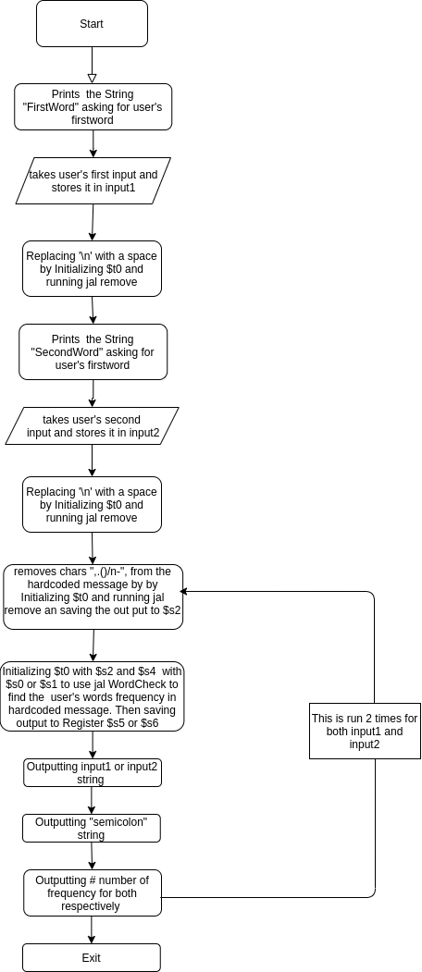Figure 1

2.0 Program Design

Firstly, I broke the code into 3 different segments to make it easier for me and reader. The three flow charts correspond respectively to the parts. The first segment consists of code that request the users for inputs ,and uses jump and link statements that connects to parts two and three to do calculations, then finally displays stats and exit using 10 for register v0. Figure 1, explains the process on how part -1 operates and its structure. It mostly uses system call statements to displays statements/messages and such to users. The second segments removes all the characters such as comma, period, left and right parenthesis in the hardcoded message ,and it also used for users inputs to replace the nextline(\n) with a space. It is first started by initializing with a “asciiz” string in part-1 to $t0 then by using jal Remove. After part-2 is started, it copies the initial string to registers $t1 and $t2, while registers $t0 and $1 are used to manipulate the string characters. It starts of by loading a character to register then comparing it to character we don’t want by using beq or bne, if it is not then stored in $t1 which deletes the character in $t2 since $t2 was set equal to $t0 and $t1 at the beginning, it will be also manipulated by removing the characters we did not store and moves on to next character. Lastly, the segment three is where most of the work is done. In segment three “WordCheck”, $s3 counter is set to zero at beginning to count the number of times word is repeated. Registers $s4 and $t0 were initialized prior part-3 is called, $s4 consists of user’s input and $t0 consists of customized message. The character are loaded onto $t3, $t4 from $t1 and $t2 respectively and they were compared by using “bne”. If they were same they move to check until “space” is reached for both of them and one is added to counter. If they have a different case, then it goes to procedures to change to upper case and by adding 32 and subtracting 64; if one of them they check same regardless of the case then “loop2” is initiated again else it goes to a procedure called space which skips until a space or null is found as a character in $t3. Part-3’s procedure is explained more in Figure 3.

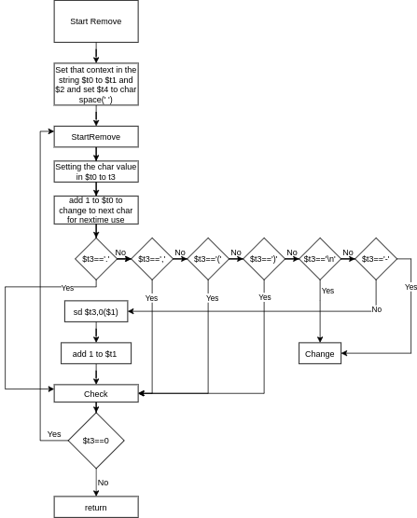Figure 2
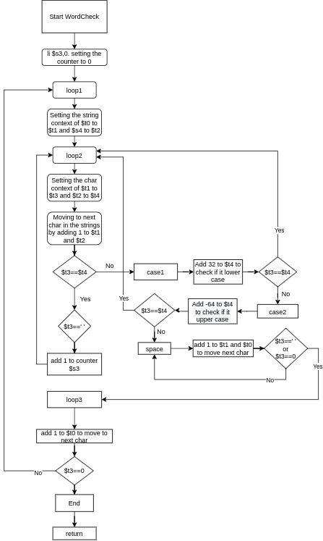Figure 3

3.0 Symbol Table

Registers | Description
Part-1 | --------------------------------------------------------------
$v0 | Used for type of output and to take input
$a0 | Used to prompt with a message or take input
$a1 | Used to give #number of space
$t0 | Initializing string for Jal Remove
$t2 | output string from Jal Remove
$s0 | User’s First input string
$s1 | User’s Second input string
$s2 | the new hardcode string without “,.()-\n”
$s3 | #counted frequency of a word from jal WordCheck
$s4 | initializing user’s input for Jal WordCheck
$s5 | # of times user’s first word was repeated
$s6 | # of times user’s second word was repeated
Part-2 | ------------------------------------------------------------------
$t0 | The string that was initialized in part1
$t1 | copy of $t0 and use to manipulate
$t2 | output string without “.,-()\n” characters
$t3 | used to load a single character to compare others
$t4 | Character ‘ ’/32
Part-3 | ----------------------------------------------------------------
$s3 | counter to count the number of times same word is found
$s4 | initialized one of input strings in part-1
$t0 | initialized customized hardcode strings in part-1
$t1 | a copy of $t0
$t2 | a copy of $s4
$t3 | used to load a single character to compare from $t1
$t4 | used to load a single character to compare from $t2

Label | Description
hardcoded_statement | The Sample Statement that was given
input1 | First word user input
input2 | Second word user input
FirstWord | The title that requests user for First input
SecondWord | The title that requests user for Second input
semi | ; in a .asciiz
nextline | \n in a .asciiz
Remove | used for jump and link to remove character like ,.()\n- aka part-2
StartRemove | call for a loop to remove
Check | checks if it is ready to return
WordCheck | used for jump and link to check the frequency of user word in message
loop1 | used to initialize registers for loop2
loop2 | a loop that checks if a word matches and add 1 to counter
case1 | checks and compares to lower case
case2 | checks and compares to upper case
space | a loop that goes to next space in a sentence
loop3 | Check if it is ready to end/return

4.0 Learning Coverage:

Provide a list of at least 5 technical topics learned from this project?
- Working with data
- Working with address
- Working with memory contents
- Working with strings
- jump and link and string manipulation tasks

5.0 Test Plan:

The inputs I will be choosing following
- GAMECOCKS and FOOTBALL
- Gamecocks and Football
- footBALL and GAMEcocks
- Williams and Brice
- THe and NcaA

6.0 Test Results:
